PROFILE OF DIRECTOR WHO ARE RETIRING BY ROTATION
AND PROPOSED TO BE RE – ELECTED

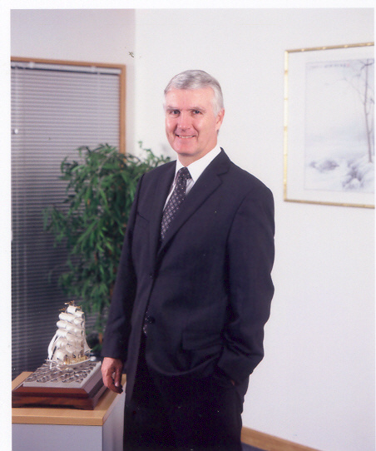
Name - Surname : Mr. Jan Dam Pedersen
Type of Director Position : Director
Age : 60
Nationality : Danish
Address : Mooban Lakewood, Soi 25
88/103 Moo 3, Bangna-Trad Km. 18
Srisajarakaeyai, Bangsaothong
Samutprakarn 10540

Education : Diploma
EAC’s full time course in Business Administration
Various high level business courses IMD Switzerland

Director Training Program : None
Shareholding in TPA : None
Work Experience during last 5 years:
August 2010 – Present - President,
Brenntag Ingredients (Thailand) Public Company Limited
(previously named The East Asiatic (Thailand) Public
Company Limited)
2001 - July 2010 - Managing Director,
Brenntag Ingredients (Thailand) Public Company Limited
(previously named The East Asiatic (Thailand) Public Company Limited)
Director / Executive Position in Other Business
Other Listed Companies : None
Other Non – Listed Companies : - President, Brenntag Ingredients (Thailand) Public Company Limited
- Director, Asiatic Acrylics Company Limited
- Director, Brenntag Enterprises (Thailand) Co., Ltd.
- Director, Brenntag Service (Thailand) Co., Ltd.
- Director, Berli Asiatic Soda Co., Ltd.
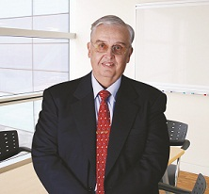
Name - Surname : Mr. Hans Henrik Melchior
Type of Director Position : Director
Age : 67
Nationality : Danish
Address : Royal River Place, Apt 31 D,
950/36 Rama III Road, Soi 38,
Bangpongpang, Yannawa,
Bangkok 10120

Education : Bachelor of Science (Marketing)
Director Training Program : None
Shareholding in TPA : None
Work Experience during last 5 years
2011– present : - Executive Director
The East Asiatic 2010 (Thailand) Company Limited
Oct 2010– present : - Director
Asiatic Acrylics Company Limited
2001 – 2010 : - Corporate Advisor
The EAC Thailand Group
: Brenntag Ingredients (Thailand) Public Company Limited
(previously named The East Asiatic (Thailand) Public
Company Limited)
1996 - 2009 : - Company Secretary
Thai Poly Acrylic Public Company Limited
Asiatic Acrylics Company Limited
1992 - 2008: - Company Secretary
The EAC Thailand Group
Director/Executive Position in Other Business
Other Listed Companies : None
Other Non-Listed Companies : - Executive Director
The East Asiatic 2010 (Thailand) Company Limited - Director Asiatic Acrylics Company Limited


Name - Surname : Miss ChaoQi Zhang

Type of Director Position : Director

Age : 41

Nationality : Chinese

Address : No. 95, Lane 688, Jian He Road, Shanghai,
China 200336

Education : MBA of Shanghai Jiao Tong University

Director Training Program : None

Shareholding in TPA : None
Work Experience during last 5 years
2004 – Present - Deputy General Manager
Financial Controller
Lucite International (China) Chemical Industry Company Limited
1998 – 2004 - Shanghai Novartis Nutrition Company Limited
1993 – 1998 - Brilliance Group Company Limited

Director/Executive Position in Other Business
Other Listed Companies : None
Other Non-Listed Companies : Deputy General Manager
Financial Controller
Lucite International (China) Chemical Industry Company Limited

