MAP OF THE LOCATION OF THE MEETING
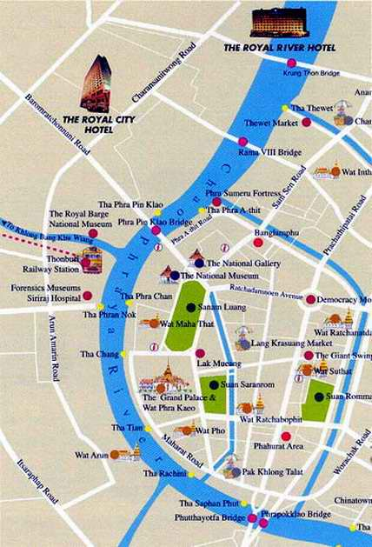
THE ROYAL CITY HOTEL
798,800 Borom Ratchonnani Rd., Bangplad, Bangkok 10700 Thailand
Tel. 02435-8888 Fax : 02434-3636
E-mail : info@royalcityhotel.com

